Implement of Augmented Reality Display and Virtual Reality User Control on Glasses

Edward Tian
2022 - 2023
PRISMS
Applied Physics

Description

A near-eye augmented reality display with simple user control using lens and ESP. A combination of augmented reality display and virtual reality control is to be designed.

Content
Description
Content
Description of Problem / Issue
Objectives
Approach
Device
Operations
Method
Timeline
Budget
Supports (including but not limited to)
Reference

Description of Problem / Issue
Augmented reality and virtual reality are the newest technologies that are still in development and they will definitely help people in the future, and a lot of researchers and companies are developing AR technologies. A lot of AR and VR products are implemented around the world, such as Google Glasses, Meta VR headset, and Microsoft AR headset in the US army.

But the products nowadays still have some issues, like the user control may not be perfect. So in this research, a AR display glass with a VR-like controller is to be developed.

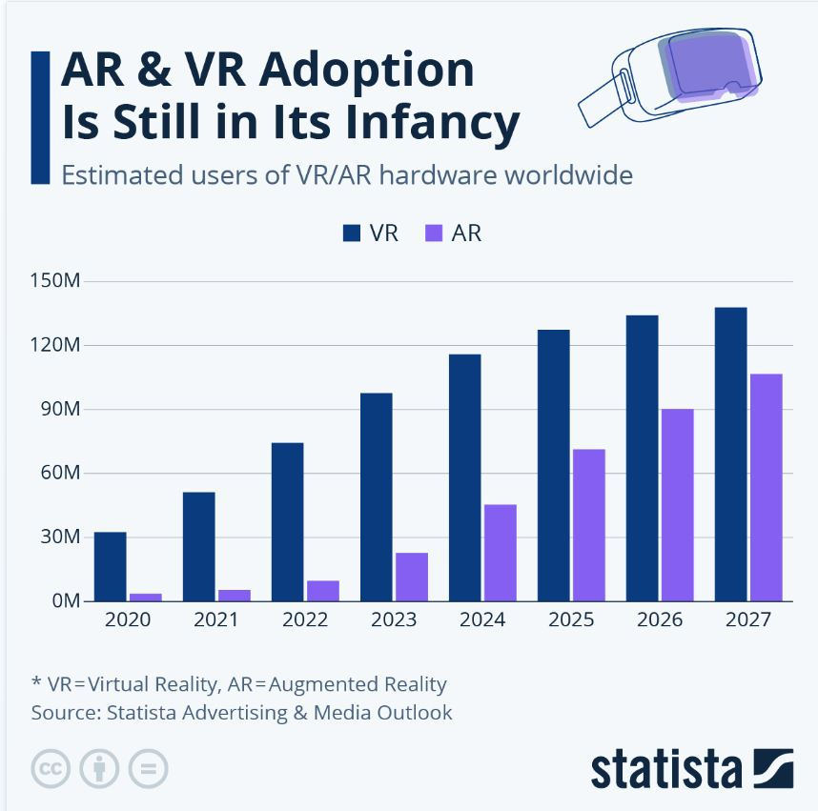

Objectives

The first objective is to successfully display the graph shown on the laptop on a large scale model. It can be in a single color, but it will be better if it is in multiple colors.

The second objective is to build a scale-downed model for the glass. A tiny projector ordered online will be implemented.

The third objective is to know the position and the angle the projector is facing. ESP and an accelerometer will be used here.

The fourth objective is to build a simple user controller. Use ESP and another accelerometer to connect the laptop with the controller, and display the graph. The model should move the same amount with the controller.

The fifth objective is to combine the third and the fourth steps together, which makes the user see the model in the place of the controller when he is wearing the glass.

The sixth objective is to build more controllers and glasses, which makes different users see the models in different positions.

Approach

To approach the first objective, I will go to the physics lab to find the proper angle of lens to display pictures on my laptop. This will reference the article I read before in article reviews, and because its formulas are wrong, I need to calculate the proper angle and lens set myself.

To approach the second objective and half of the fourth, I will use the 3D printer in PiLab to print the structure of my scale-downed model. This phase just takes time to model and print the model.

To approach the third objective, the other half of the fourth objective, and the fifth objective, I will learn how to compile with ESP and Bluetooth and utilize the data from ESP in a new Unity project. The displayed thing on the projector will be the scene in the Unity project.

The first five objectives could be enough for a final product. And for the sixth objective, it’s an additional approach if I still have time after the five objectives are accomplished. It’s just repeating what I did before in the former steps. But it might be another issue to show different graphs on different projectors and connect too many devices with Bluetooth.

Device
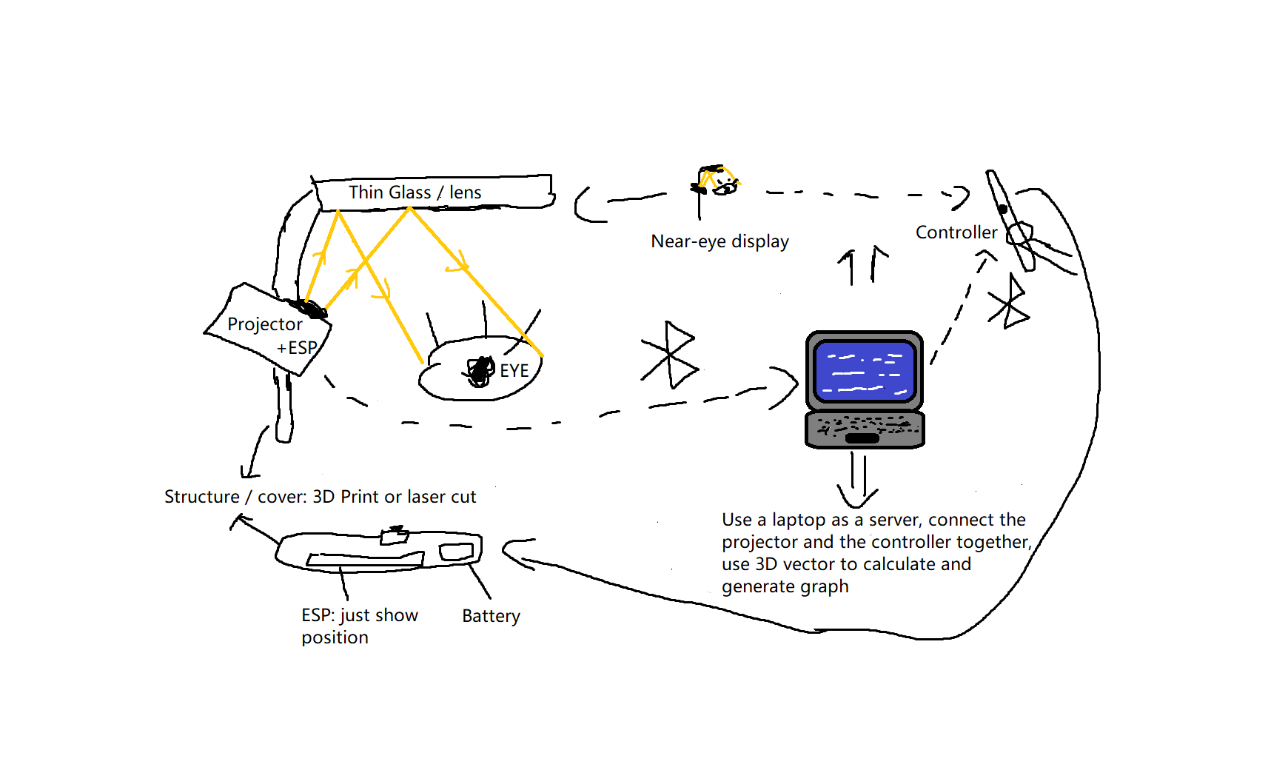

Operations
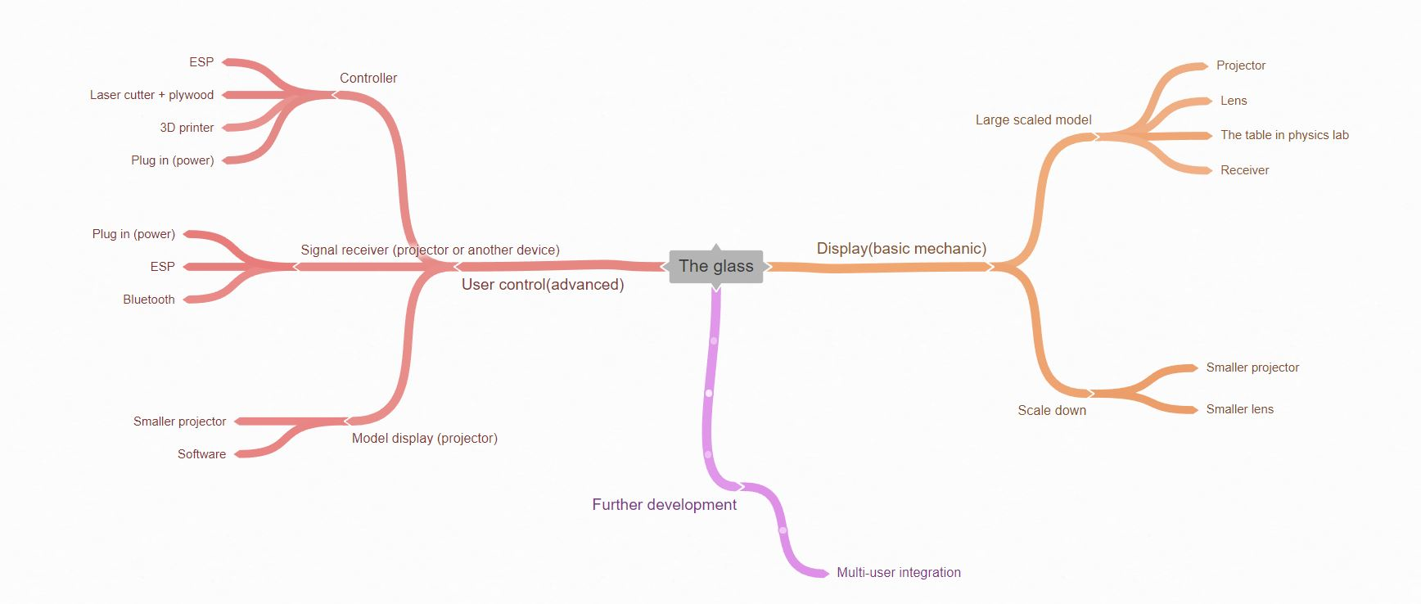

Method
Phase 1: Geometrical optics calculations. The expected result should be like the outcome in the research paper I read before. I’ll use the tables and lens in the physics lab. I might need Dr. Weijing Wang’s support in this phase.

Phase 2 & 4: Applied Engineering works. I’ll use some small lenses, and the 3D printers and laser cutters in PiLab. I might need Mr. Heim and Mr. Kemp’s support in this phase.

Phase 3, 4 & 5: Receiving data from ESP, and then sending them into a Unity project. I need ESP-related stuff in PiLab. I might need Mr. Heim, Mr. Kemp and Mr. Tang’s support in this phase.

Timeline
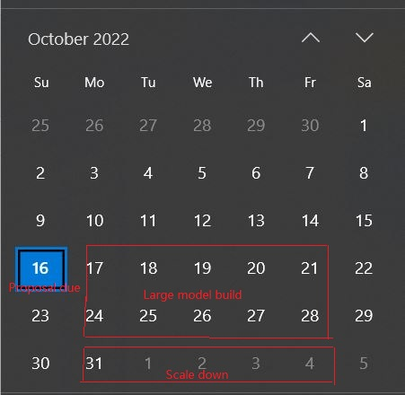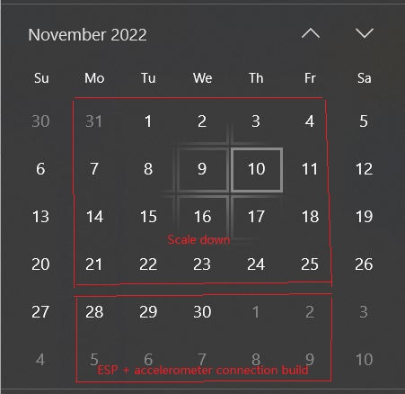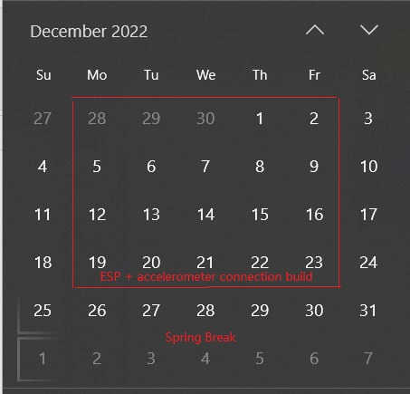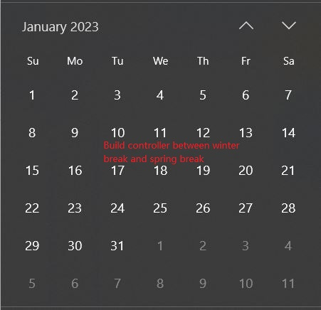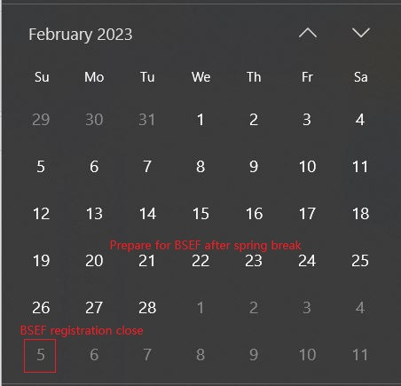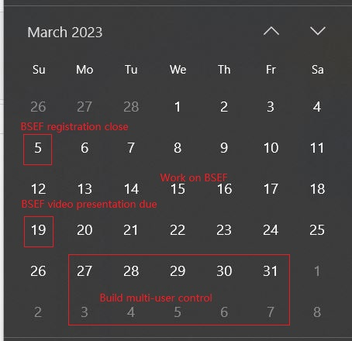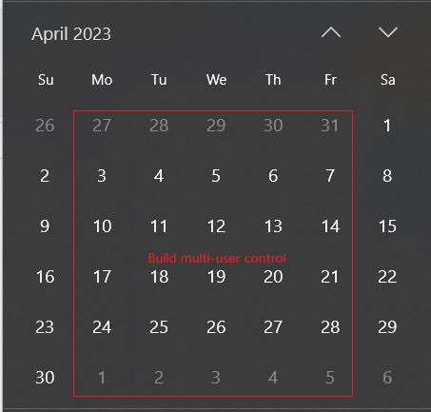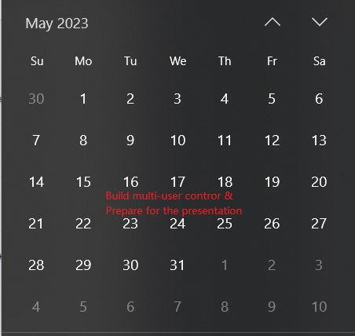

Budget

Name | Supplier | Price per Unit | Quantity | Estimated cost | Reason
AAXA Pico KP10101 (Small Projector) | Amazon | $125.99 | 1 | $130 | For the scale down model
Accelerometer or Magnetometer | Amazon | Less than $10 | 2 | $20 | To know where the projector and controller are facing
USB A to A cable (30 ft) | Amazon | $9.99 | 1 | $10 | To connect the projector and laptop

Supports (including but not limited to)
Advisors: Mr. Heim, Dr. Weijing Wang, Mr. Kemp, Mr. Tang.
Consumable parts: ESP related stuff in PiLab,(Nov 2022 - May 2023) Lenses in Physics Lab (Oct 2022 - May 2023)
Equipment: A laser projector in any classroom,(Oct 2022 - Nov 2022) Optics equipment in Physics lab,(Oct 2022 - Nov 2022) 3D printer and laser cutter in PiLab (Nov 2022 - Feb 2023)

Clarity: If someone else is using the same equipment at the same time with me, I’ll talk with them to share the equipment.

Reference
- Seokil Moon, Chang-Kun Lee, Seung-Woo Nam, Changwon Jang, Gun-Yeal Lee , Wontaek Seo, Geeyoung Sung, Hong-Seok Lee & Byoungho Lee. (2019). Augmented reality near-eye display using Pancharatnam-Berry phase lenses. Nature, 9:6616.
- Felix Richter, AR & VR Adoption Is Still in Its Infancy, Statisia, https://www.statista.com/chart/28467/virtual-and-augmented-reality-adoption-forecast/
- Maggie Harrison, Microsoft's AR Headset was a Complete Disaster During a Military Test, Futurism, https://futurism.com/the-byte/microsoft-headset-disaster-military-test

